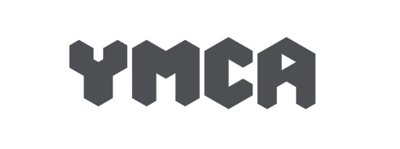8

**POST:** Maintenance Operative

**RESPONSIBLE TO:** Senior Maintenance (Head of Housing Services)

**HOURS:** 37.5 hoursper week between the hours of 8am – 16:00pm Monday to Friday, (flexibility is expected to suit the needs of the project and some weekends maybe needed)

*\*Please note: The organisation is currently discussing the possibility of implementing a 100-80-100 model of the 4 day working week arrangement from 2025.*

**SALARY:** Starting at £23400 per annum

**ORGANISATIONAL AIMS:**

1. To provide temporary hostel accommodation to homeless people
2. To develop a range of accommodation options and individual capacity building
3. To manage the Association and its projects with good practice and within statutory guidance.

**JOB PURPOSE:**

**To work as a team to maintain the Associations premises and related tenancies under the supervision of the Senior Maintenance Operative and the management of the Head of Housing Services (or in her/his absence, The Housing Manager).**

***We have an exciting opportunity for a Maintenance Operative to join our team!***

The closing date for application is Friday 24th January 2025. Successful applicants at the first stage of interview will be invited to progress to the second stage where you will attend a trial shift with our Maintenance Team.

Applicants will only be contacted if they are successful in securing an interview.

To join our team and for further job details, job description, person specification and online application form please go to our website at www.ymcacardiff.wales

If you have any questions, please contact Laura Jones HR Advisor on 02920465250

An enhanced DBS Disclosure is required for this post.

*YMCA Cardiff is an equal opportunity employer dedicated to a policy of non-discrimination in employment on any basis including race, colour, religion, sex, national origin, age, disability, sexual orientation, marital status, or any other class protected by law.*

**WHY WORK FOR US?**

Be part of the YMCA team that has been in existence since 1852!

* Generous pension scheme
* Competitive Salary
* Group Life Insurance
* Cycle to Work scheme
* Private Health Scheme
* Online HR system giving access to book your annual leave from a mobile/tablet
* Group team days
* Enhanced annual leave allowance

*“Always being encouraged to try new things to develop and broaden my skills – there are opportunities if I want to progress”*

*“I love working here - love the job, love the people and love the atmosphere”.*